The Learning Problem HW3

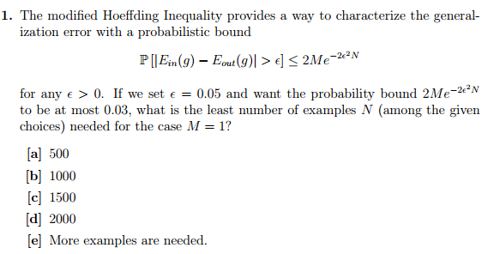

$$P\left[\left|E_{in}\left(g\right)-E_{out}\left(g\right)\right|>ϵ\right]≤2Me^{- 2ϵ^{2}N}$$

$$0.03≤2(1)e^{- {2*0.05}^{2}N}$$

$$\frac{0.03}{2}≤e^{- {2*0.05}^{2}N}$$

$$\frac{0.03}{2}≤e^{- {2*0.05}^{2}N}$$

$$ln⁡\left(\frac{0.03}{2}\right)≤-{2*0.05}^{2}N$$

$$\frac{1}{-2({0.05}^{2})}ln⁡\left(\frac{0.03}{2}\right)≤N$$

$$839.941≈840≤N$$

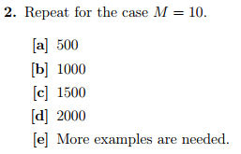

$$P\left[\left|E_{in}\left(g\right)-E_{out}\left(g\right)\right|>ϵ\right]≤2Me^{- 2ϵ^{2}N}$$

$$0.03≤2(10)e^{- {2*0.05}^{2}N}$$

$$\frac{0.03}{2}≤e^{- {2*0.05}^{2}N}$$

$$\frac{0.03}{2}≤e^{- {2*0.05}^{2}N}$$

$$ln⁡\left(\frac{0.03}{20}\right)≤-{2*0.05}^{2}N$$

$$\frac{1}{-2({0.05}^{2})}ln⁡\left(\frac{0.03}{20}\right)≤N$$

$$1300.46≈1301≤N$$

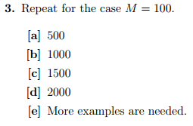

$$P\left[\left|E_{in}\left(g\right)-E_{out}\left(g\right)\right|>ϵ\right]≤2Me^{- 2ϵ^{2}N}$$

$$0.03≤2(100)e^{- {2*0.05}^{2}N}$$

$$\frac{0.03}{2}≤e^{- {2*0.05}^{2}N}$$

$$\frac{0.03}{2}≤e^{- {2*0.05}^{2}N}$$

$$ln⁡\left(\frac{0.03}{200}\right)≤-{2*0.05}^{2}N$$

$$\frac{1}{-2({0.05}^{2})}ln⁡\left(\frac{0.03}{200}\right)≤N$$

$$1760.98≈1761≤N$$

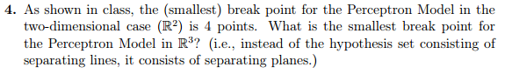

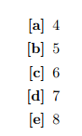

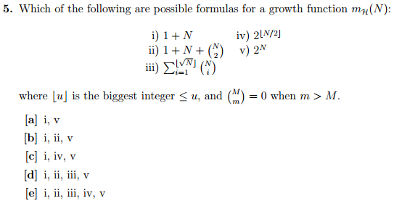

Correction: I didn’t fully understand the implications of the proof that if a growth function has a break point $k$ then it possesses a polynomial upper bound. As such, 3 and 4 are not possible growth functions. The answer is b.

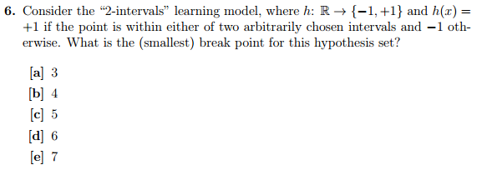

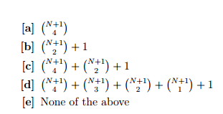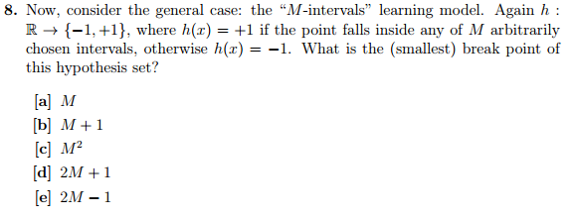

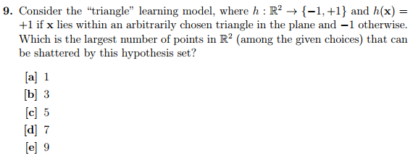

Correction: Did analysis after selecting points to *minimize* the breakpoint instead of *maximize it*. Grouping any arbitrary set of four point is possible with N=5, but not with N=7.

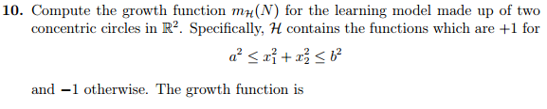

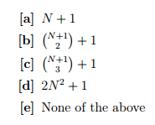

The worst case scenario here is all the points in a line that intersects the radius of the circles (at which point analyzing the number of dichotomies becomes the same as analyzing the number of dichotomies for the two-ray problem).

Grade:

Incorrect answers:

* #5 (I didn’t fully understand implications of proof that if there is a breakpoint, the growth function has a polynomial upper bound)
* #9 (accidentally selected N to minimize the break point instead of maximize it)

